Birla Institute of Technology & Science, Pilani
Work Integrated Learning Programmes Division
First Semester 2023-2024

Comprehensive Examination
(EC-3 Regular)

Course No. : SE ZG519
Course Title : Data Structures and Algorithms Design
Nature of Exam : Open Book
Pattern of Exam : Typed Only
Weightage : 40%
No. of Pages = 6

No. of Questions = 6
Duration : 2 ½ Hours
Date of Exam : 25/11/2023 (FN)
Note to Students:
- Please follow all the Instructions to Candidates given on the cover page of the answer book.
- All parts of a question should be answered consecutively. Each answer should start from a fresh page.
- Assumptions made if any, should be stated clearly at the beginning of your answer.

Q-1  (Set A) | Determine the value of x and y (in terms of n) at the end of the execution of the following algorithms algo1 and algo2. (5 marks + 5 marks)  (Note: Partial marking will not be done for this question.) | 10 Marks
  Algorithm algo1(integer n)  x ← 0  for i = 0; i < n; i = i+1 do  for j = 0; j < 2*n; j = j+1 do  x ← x+1 | Algorithm algo1(integer n)  y ← 0  for i = 0; i < n; i = i+1 do  for j = 0; 2*j < n; j = j+1 do  y ← y+1
Q-1  (Set B) | Determine the value of x and y (in terms of n) at the end of the execution of the following algorithms algo1 and algo2. (5 marks + 5 marks)  (Note: Partial marking will not be done for this question.) | 10 Marks
  Algorithm algo1(integer n)  x ← 1  for i = 0; i < n; i = i+1 do  for j = 0; j < 2*n; j = j+1 do  x ← x*2 | Algorithm algo1(integer n)  y ← 0  for i = 0; i < n; i = i+1 do  for j = 0; 2*j < n; j = j+1 do  y ← y*2
Q-2  (Set A) | Prof. Forget was working on the Merge sort algorithm. He got to sleep while writing the algorithm and forgot to write the underlined steps in MERGE algorithm. If he executes his faulty algorithm MERGE_SORT(arr, 0, 5) on arr = {16, 13, 11, 15, 12, 14}, then what will be the modified arr at the end of execution? You are supposed to write the values of modified arr only as your answer.  (Note 1: Partial marking will not be done for this question.)  (Note 2: Consider array arr starts from the index 0 here.) | 10 Marks
  MERGE_SORT(arr, beg, end)  if beg < end then  mid ← (beg + end)/2  MERGE_SORT(arr, beg, mid)  MERGE_SORT(arr, mid + 1, end)  MERGE (arr, beg, mid, end)  END MERGE_SORT | MERGE(arr, beg, mid, end){  n1 ← mid - beg + 1  n2 ← end - mid  Initialize LeftArray[n1], RightArray[n2]  for i = 0 to n1 do  LeftArray[i] ← arr[beg + i]  for j = 0 to n2 do  RightArray[j] ← arr[mid + 1 + j]  i ← 0  j ← 0  k ← beg  while i < n1 and j < n2 do  if(LeftArray[i] <= RightArray[j])then  arr[k++] ← LeftArray[i++]  else  arr[k++] ← RightArray[j++]  while i<n1 do  arr[k++] ← LeftArray[i++]  while j<n2 do  arr[k++] ← RightArray[j++]  }
Q-2  (Set B) | Mr. Raju was devising the Merge sort algorithm. He got to confused while writing the algorithm and wrote faulty steps as underlined in MERGE algorithm. If he executes his faulty algorithm MERGE_SORT(arr, 0, 5) on arr = {16, 13, 11, 15, 12, 14}, then what will be the modified arr at the end of execution? You are supposed to write the values of modified arr only as your answer.  (Note 1: Partial marking will not be done for this question.)  (Note 2: Consider array arr starts from the index 0 here.) | 10 Marks
  MERGE_SORT(arr, beg, end)  if beg < end then  mid ← (beg + end)/2  MERGE_SORT(arr, beg, mid)  MERGE_SORT(arr, mid + 1, end)  MERGE (arr, beg, mid, end)  END MERGE_SORT | MERGE(arr, beg, mid, end){  n1 ← mid - beg + 1  n2 ← end - mid  Initialize LeftArray[n1], RightArray[n2]  for i = 0 to n1 do  LeftArray[i] ← arr[beg + i]  for j = 0 to n2 do  RightArray[j] ← arr[mid + 1 + j]  i ← 0  j ← 0  k ← beg  while i < n1 and j < n2 do  if(LeftArray[i] <= RightArray[j])then  arr[k++] ← RightArray[j++]  else  arr[k++] ← LeftArray[i++]  while i<n1 do  arr[k++] ← LeftArray[i++]  while j<n2 do  arr[k++] ← RightArray[j++]  }
Q-3  (Set A) | Prof. Forget used to make tricky questions for students. He gave postorder traversal sequence x y z + w * + for a tree of an expression. He also gave a formation of this tree with labels {1,2,3,4,5,6,7} as follows.  (a) If x = 10, y = 20, z = 30, and w = 40, then identify the value after evaluating this expression.  (b) Write values of labels 1 = __, …, 7 = __. (5 Marks)  (Note: Partial marking will not be done for this question.)  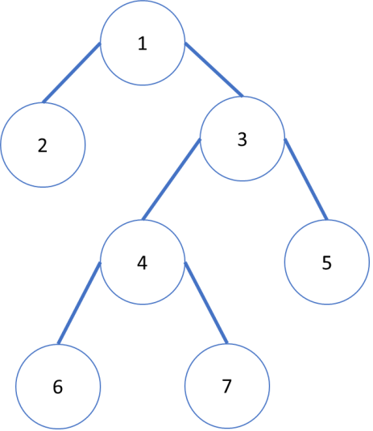 | 10 Marks
Q-3  (Set B) | Prof. Forget used to make tricky questions for students. He gave prefix traversal sequence + + a * b c * d + e f for a tree of an expression. He also gave a formation of this tree with labels {L1, L2, L3, L4, L5, L6, L7, L8, L9, L10, L11} as follows.  (a) If x = 10, y = 20, z = 30, and w = 40, then identify the value after evaluating this expression. (5 Marks)  (b) Identify the values of labels L1 = __, …, L11 = __. (5 Marks)  (Note: Partial marking will not be done for this question.)  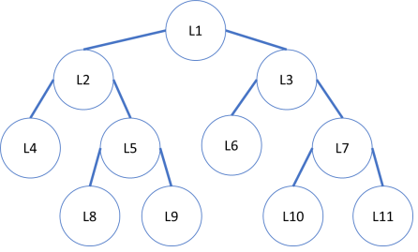 | 10 Marks
Q-4  (Set A) | Sometimes students challenge Prof. Forget by writing a faulty algorithm. A student wrote two algorithms for checking balanced parentheses and challenged Prof. Forget to find input strings for which her algorithms give wrong output. You need to write one input string for algorithm Parenthesis1 and one input string for algorithm Parenthesis2 as your answer. (5 marks + 5 marks)  (Note: Partial marking will not be done for this question.) | 10 Marks
  Algorithm Parenthesis1 (IP)  //IP is a string of parenthesis  //S is stack that is initially empty  for i = 1 to IP.length do  if IP[i] = '(' then  PUSH(S, IP[i])  else if IP[i] = ')' AND  Stack.empty( ) = FALSE  POP(S)  else  PRINT("Unbalanced")  Exit  PRINT("Balanced") | Algorithm Parenthesis2 (IP)  //IP is a string of parenthesis  //S is stack that is initially empty  for i = 1 to IP.length do  if IP[i] = '(' then  PUSH(S, IP[i])  else if IP[i] = ')' OR  Stack.empty = FALSE  POP(S)  else  PRINT("Unbalanced")  Exit  PRINT("Balanced")
Q-4  (Set B) | Ms. Neha is learning recursive algorithms. She made the following algorithms for stack and queue data structures. Find out the values in stack and queue after executing the following algorithms on the given stack and queue. You need to write values of stack and queue with values of top of the stack, front-rear of the queue as your answer.  (5 marks + 5 marks)  (Note: Partial marking will not be done for this question.) | 10 Marks
  Algorithm Unknown1 (S)  //S is a stack with values {11,12,13,14,15} where top of stack (tos) is pointing to 15.  d ← 0  if tos != 0 then  d ← pop(S)  Unknown1(S)  push(S, d) | Algorithm Unknown2(Q)  //Q is a queue with values {11,12,13,14,15}, where front (f) is pointing to 11 and rear (r) is pointing to 15.  d ← 0  if f != 0 then  d ← dequeue(Q)  Unknown2(Q)  enqueue(Q, d)
Q-5  (Set A) | Prof. Bhide likes to trick Mr. Jethalal. He has a graph of Gokuldham as shown in the following figure. Prof. Bhide asked Mr. Jethalal to visit all 0 to 8 houses with minimum energy requirement. Edges on graph are showing energy required to walk from a house to another house. During odd hours, Mr. Jethalal needs to spend energy. Hence, during odd hours, edges are having positive values, (e.g, edge between 0 and 1 will have value 4). During even hours, Mr. Jethalal gains energy through Fafda-Jalebi food on the route. Hence, during even hours, all edges are having same negative values, (e.g., edge between 0 and 1 will have value -4).  Use Prim's algorithm to find minimum spanning tree for Mr. Porter to cover all rooms with minimum energy. Assume that you starts with odd hours and require exact 1 hour to find a minimum edge. Assume that starting vertex for Prim's algorithm is 0.  As your answer, you need to write the sequence of edges chosen during execution of Prim's algorithm and the total minimum energy requirements to visit all the rooms.  Sequence of edges = {_,_},{_,_},...  Total Energy Required = __________  (5 Marks + 5 Marks)  (Note: Partial marking will not be done for this question.)  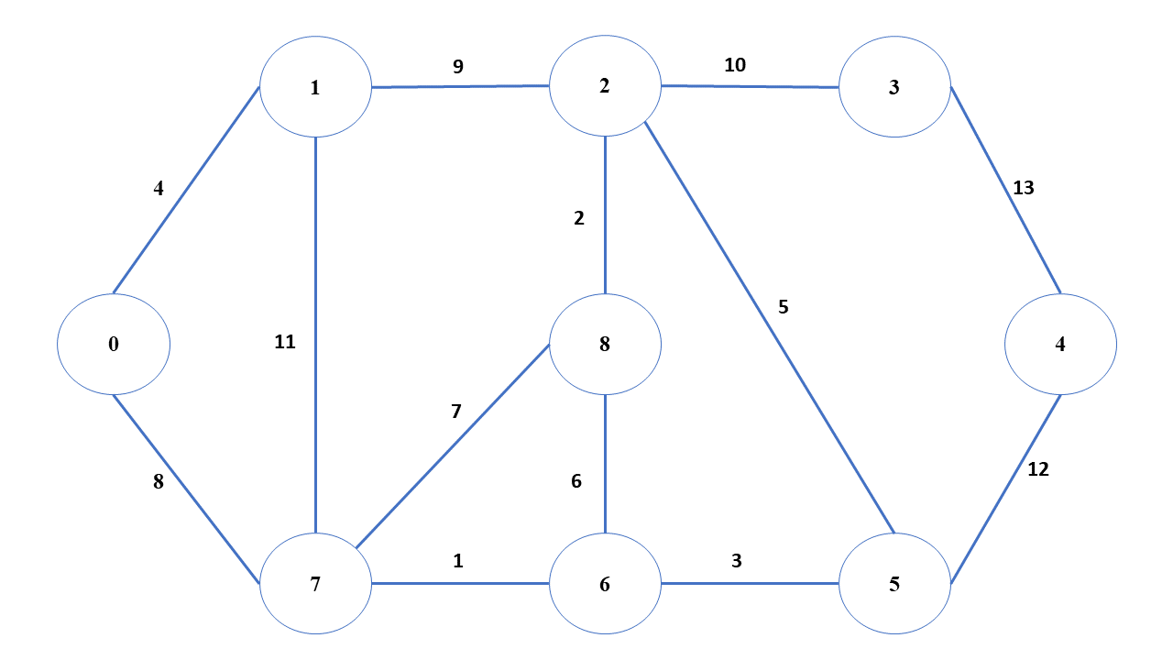 | 10 Marks
Q-5  (Set B) | Prof. Snape likes to trick Mr. Porter. He has a graph of Hogwarts as shown in the following figure. Prof. Snape asked Mr. Porter to visit all 0 to 8 rooms with minimum energy requirement. Edges on graph are showing energy required to walk from a room to another room. During odd hours, Mr. Porter needs to spend energy. Hence, during odd hours, edges are having positive values, (e.g, edge between 0 and 1 will have value 4). During even hours, Mr. Porter gains energy through chocolates on the route. Hence, during even hours, all edges are having same negative values, (e.g., edge between 0 and 1 will have value -4).  Use Kruskal's algorithm to find minimum spanning tree for Mr. Porter to cover all rooms with minimum energy. Assume that you starts with odd hours and require exact 1 hour to find a minimum edge.  As your answer, you need to write the sequence of edges chosen during execution of Kruskal's algorithm and the total minimum enery requirements to visit all the rooms.  Sequence of edges = {_,_},{_,_},...  Total Energy Required = __________  (5 Marks + 5 Marks)  (Note: Partial marking will not be done for this question.) | 10 Marks
Q-6  (Set A) | A mathematician came to Prof. Forget for solving a large binomial coefficients using algorithms. He gave the following formula to Prof. Forget for solving the problem.  BC(n, k) = 0 (if k > n)  or = 1 (if k = 0 or k = n)  or = BC(n-1, k-1) + BC(n-1, k) (Otherwise)  Prof. Forget made the following recursive algorithm for the same. But he is not happy as this algorithm computes the same BC(i, j) multiple times as shown in below table.  He asked you to devise an algorithm using dynamic programming. You need to write formula of dynamic programming for this problem (6 marks), algorithm using dynamic programming (12 marks), and derivation matrix of BC(4,2) using your algorithm (12 marks). (Hint: Recall Fibonacci Problem using dynamic programming). | 30 Marks
  Algorithm BC(integer n, integer k)  if k > n then  Return 0  else if k = 0 or k = n then  Return 1  else  Return BC(n-1, k-1) + BC(n-1, k) | List of recursive calls for BC(4,2):  BC(4,2) = BC(3,1) + BC(3,2)  BC(3,1) = BC(2,0) + BC(2,1)  BC(2,0) = BC(1,-1) + BC(1,0)  BC(2,1) = BC(1,0) + BC(1,1)  BC(1,0) = BC(0,-1) + BC(0,0)  BC(1,1) = BC(0,0) + BC(0,1)  BC(3,2) = BC(2,1) + BC(2,2)  BC(2,1) = BC(1,0) + BC(1,1)  BC(1,0) = BC(0,-1) + BC(0,0)  BC(1,1) = BC(0,0) + BC(0,1)  BC(2,2) = BC(1,1) + BC(1,2)
Q-6  (Set B) | Prof. Bhide gave a tough question paper for a given time limit. Tapu went through the question paper and noted marks and no. of minutes required to solve the each question. Tapu gave this note to you and asked to get the sequence of questions numbers for scoring as much as possible.  (a) You need to write an algorithm using dynamic programming to find such sequence of question numbers (15 marks).  (b) You need to write matrix (5 marks), possible maximum marks (5 marks), and sequence of question numbers to be attempted (5 marks) using your algorithm for the following input. Assume that maximum time for test is 10 minutes. | 30 Marks
   | Q-1 | Q-2 | Q-3 | Q-4 | Q-5 | Q-6 | Q-7
  Time required | 1 | 1 | 2 | 3 | 3 | 4 | 5
  Marks | 5 | 8 | 4 | 9 | 10 | 7 | 15

